System requirements specification

Medical Wristband Body Temperature Monitor

Mr JH van Dyk

30254906

Document Identification

|  |  |
| --- | --- |
| Project Title: | System Requirements Specification – Medical Wristband Body Temperature Monitor |
| Document Number: | SyRS-MWBTM_v1.0 |
| System / Sub-System: | Medical Wristband Body Temperature Monitor |
| Document Issue Date: | 2021-04-28 |
| Client: | Prof A Helberg – NWU |
| Client Reference: | MWBTM |

Origination and Approval

|  |  |  |  |
| --- | --- | --- | --- |
| Checked by Party | Individual Name | Signature | Date |
| Author: | Mr JH van Dyk |  | 2021-04-28 |
| Quantity Assurance: |  |  |  |
| Technical Approval: | Prof A Helberg |  |  |
| Project Manager: | Prof Leenta Grobler |  |  |

Acceptance

|  |  |  |  |
| --- | --- | --- | --- |
| Checked by | Individual Name | Signature | Date |
| Approved by: |  |  |  |

Distribution List

|  |  |  |
| --- | --- | --- |
| Company | Individual Name | Date |
| NWU | Prof A Helberg |  |
|  |  |  |
|  |  |  |
|  |  |  |

Security Levels and Restrictions

|  |  |  |
| --- | --- | --- |
| Level | Description | Applicable Level |
| 1 | Strictly Confidential – not to be distributed |  |
| 2 | Company Confidential – distributed inside company |  |
| 3 | Client Confidential – distributed to limited clients and contractors | X |
| 4 | Public Domain – distributed freely |  |

Contact Information

|  |  |
| --- | --- |
| Contact Person | Mr JH van Dyk |
| Company | NWU – EERI474 2021 |
| Street Address | 14 Malherbe Street, La Bella Vie, Potchefstroom, 2520 |
| Telephone Number | 072 968 3125 |
| Email address | 30254906@student.g.nwu.ac.za |
| Web site | None |

DOCUMENT REVISION HISTORY

|  |  |  |  |
| --- | --- | --- | --- |
| Date | Responsible person | Description | Revision No. |
| 2021-04-28 | JH van Dyk | Document creation | 1.0 |
|  |  |  |  |
|  |  |  |  |
|  |  |  |  |

**Table of Contents**

Document Identification 2

Origination and Approval 2

Acceptance 2

Distribution List 2

Security Levels and Restrictions 2

Contact Information 2

DOCUMENT REVISION HISTORY 3

1 Introduction and scope 6

1.1 Identification 6

1.2 Intended use 6

1.3 System Overview 6

1.4 Document Overview and Use 7

2 Applicable and other referenced documents 7

2.1 Applicable documents 7

2.2 Other referenced documents 7

3 Meanings, Acronyms, and Abbreviations 7

3.1 Meanings 7

3.2 Acronyms 7

3.3 Abbreviations 7

4 Requirements 8

4.1 Identification of External Interfaces 8

4.1.1 User interface 8

4.1.2 Wristband interface 8

4.2 Identification of States and Modes 8

4.2.1 States 8

4.2.2 Modes 8

4.3 System Function and Performance Requirements 9

4.3.1 Temperature measuring function 9

4.3.2 Timekeeping function 9

4.4 Relationships between States and Modes 9

4.4.1 Powered-down state(off) 9

4.4.2 Powered state(on) 9

4.4.3 Failure state 9

4.5 System External Interface Requirements 10

4.5.1 User interface 10

4.5.2 Wristband interface 10

4.6 System Environmental Requirements 10

4.6.1 Classes of environment 10

4.6.2 Operational Environment 10

4.7 External Resource Utilization Requirements 10

4.8 System Physical Requirements 10

4.9 Other System Qualities 10

4.10 Design and Construction Requirements 10

4.10.1 General Design and Construction Requirements 10

4.10.2 Characteristics of sub-ordinate elements 10

4.11 Precedence of requirements 11

5 Verification requirements 11

# Introduction and scope

## Identification

This system specification pertains to the Medical Wristband Body Temperature Monitor being developed by the North West University (NWU).

## Intended use

Conventional body temperature measuring devices are primarily invasive, resulting in discomfort for some. Non-invasive devices solve this problem, however, they are not always very accurate. Therefore, the medical wristband body temperature monitor is intended to be used by anyone with the need to accurately measure body temperature, quickly and on the go.

The measuring device will be attached to a wristband that can be worn on the wrist of a person, with the intention to continuously measure and monitor as well as to display the body temperature of the individual wearing the device.

## System Overview

Figure 1(a) shows the functional block diagram of the Medical Wristband Body Temperature Monitor and its interfaces with the user of the device and the wristband containing the measuring device. Figure 1(b) shows the basic block architecture of the Body Temperature Measuring Device.

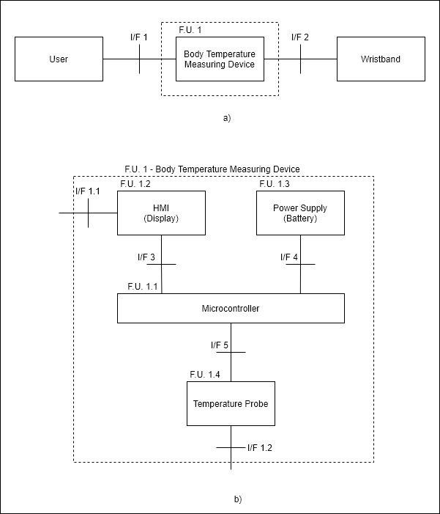

Figure 1 - (a) System context and interfaces. (b) Basic block architecture of the device.

## Document Overview and Use

This SyRS is intended to be used by the client and their appointed contractors to develop the Medical Wristband Body Temperature Monitor. Unless explicitly stated herein all contents of this SyRS is to be treated as client confidential by any contractors. At the discretion of the client, this SyRS may be distributed to any party deemed to have a stake in the development of this system or the management of the system development.

# Applicable and other referenced documents

## Applicable documents

N/A

## Other referenced documents

Unless explicitly states any requirement in this specification that is found to be in conflict with the referenced standards shall be considered to be subservient to said standard.

# Meanings, Acronyms, and Abbreviations

## Meanings

Unless otherwise explicitly states here all words and terms shall be interpreted as per the latest edition of the United Kingdom variant of the Oxford English dictionary.

|  |  |
| --- | --- |
| TERM | DEFINITION |
| shall | Expresses a characteristic that must be present in the item of specification, thus a binding requirement. |
| should | Expresses a goal or target to be pursued but not necessarily achieved |
| may | Expresses permissive guidance. |
| will | Expresses a declaration of intent on the part of a party. |
| STATE | The state of a system refers to a state of being of the system. |
| MODE | The mode of a system refers to the state of doing of a system. Typically, modes are encapsulated within states. |

## Acronyms

|  |  |
| --- | --- |
| Acronym | DEFINITION |
| NWU | North West University |
| Syrs | System Requirements Specification |
| tbd | To Be Defined |

## Abbreviations

|  |  |
| --- | --- |
| ABBREVIATION | Explantation |
| e.g. | For example. |
| REQID | Requirement Identifier |
| MWBTM | Medical Wristband Body Temperature Monitor |
| N/A | Not Available / Not Applicable |

# Requirements

## Identification of External Interfaces

### User interface

An interface that can be used to control the MWBTM and to obtain information regarding the measured body temperature and current time. **REQID**_**0001**

An interface by which the MWBTM measures body temperature when in contact with the skin of the user. **REQID**_**0002**

### Wristband interface

An interface to mount the MWBTM on a wristband so that it can be worn on the wrist of the user. **REQID**_**0003**

## Identification of States and Modes

The system shall have the following states and modes as defined in Section 3.1

### States

#### Powered-down state (off)

The MWBTM shall only be in powered-down state when the supply power to the device (battery) is removed. **REQID**_**0004**

#### Powered state (on)

The MWBTM shall transition to the powered state once power (battery) is supplied to the device. **REQID**_**0005**

#### Failure state

Should any of the measuring device’s components fail or exhibit abnormal behaviour, the MWBTM shall transition to a state of failure. **REQID**_**0006**

### Modes

#### Measuring mode

The MWBTM shall be in measuring mode at all times, except when the user specifically requests other modes. **REQID**_**0007**

In measuring mode, the MWBTM shall measure the body temperature of the user. **REQID**_**0008**

The system shall provide the user with the current measured body temperature via the user interface when in measuring mode. **REQID**_**0009**

#### Time mode

The MWBTM shall transition to time mode upon request from the user via the user interface. **REQID**_**0010**

In the time mode, the MWBTM shall provide the user with the current time of day. **REQID**_**0011**

#### Alarm mode

The system shall, when in alarm mode, immediately alert the user about the potentially high/low body temperature via the user interface. **REQID**_**0012**

#### Settings mode

The system shall transition to the settings state upon request from the user via the user interface. **REQID**_**0013**

The system shall when in the settings state, allow the user to set the current time of day via the user interface. **REQID**_**0014**

The system shall store the time set by the user for normal timekeeping. **REQID**_**0015**

## System Function and Performance Requirements

### Temperature measuring function

In measuring mode, the MWBTM shall measure the body temperature of the user only when the device is in contact with the skin of the user. **REQID**_**0016**

The MWBTM shall measure the body temperature of the user with an accuracy of no less than ±0.5°C. **REQID**_**0017**

Upon entering measuring mode, the system shall provide a body temperature reading within 5 minutes. **REQID**_**0018**

The MWBTM shall, when in measuring mode, measure body temperatures ranging between 30°C and 40°C. **REQID**_**0019**

The MWBTM shall alarm the user when the measured body temperature of the user drops below 36°C or exceeds 38°C. **REQID**_**0020**

### Timekeeping function

The system shall, at all times, keep the current time as set by the user. **REQID**_**0021**

The MWBTM shall when in time mode, display the current time in 12h format to the user via the user interface. **REQID**_**0022**

## Relationships between States and Modes

### Powered-down state(off)

In the powered-down state, the MWBTM is completely inactive, and not performing any functions. **REQID**_**0023**

### Powered state(on)

In the powered state, the MWBTM shall be fully functional. **REQID**_**0024**

All modes of operation are allowed in the powered state. **REQID**_**0025**

### Failure state

No modes of operation are allowed in the failure state. Once the error condition has been resolved the MWBTM can be power cycled to exit the failure state. **REQID**_**0026**

## System External Interface Requirements

### User interface

The user interface shall provide the user with the means to cycle between measuring mode, time mode, and settings mode. **REQID**_**0027**

The user interface shall provide the user with the current measured body temperature with an accuracy of no less than ±0.5°C. **REQID**_**0028**

The user interface shall provide the user with the current time when in time mode, refreshing every minute. **REQID**_**0029**

### Wristband interface

The wristband interface shall make provision for mechanically connecting the device to a wristband that can be worn on the user’s wrist. **REQID**_**0030**

## System Environmental Requirements

### Classes of environment

For the purposes of this SyRS, only the operational environment is defined, with transportation and storage environments being contained within the parameter envelopes of the operational environment.

### Operational Environment

The MWBTM shall maintain full functionality within the operational environment for all temperatures between -5°C and 40°C and relative humidity not exceeding 90%. **REQID**_**0031**

The MWBTM must not be exposed to water. **REQID**_**0032**

## External Resource Utilization Requirements

The MWBTM shall be powered by a 3.3V battery and consume very low power from the battery. **REQID**_**0033**

## System Physical Requirements

The MWBTM system, when fully deployed in an operational context, shall have a maximum bounding box of no more than 30mm x 30mm x 10mm. **REQID**_**0034**

The MWBTM should weigh less than 100g with the power source included. **REQID**_**0035**

## Other System Qualities

The MWBTM shall be designed in such a way that the battery replacement procedure can be done easily. **REQID**_**0036**

## Design and Construction Requirements

### General Design and Construction Requirements

The MWBTM wristband may be manufactured by means of additive manufacturing technologies. **REQID**_**0037**

### Characteristics of sub-ordinate elements

The MWBTM device shall not make use of materials or components that is harmful to the skin of a human. **REQID**_**0038**

## Precedence of requirements

All requirements stated herein are subservient to requirements of safety. Should the satisfaction of a requirement lead to the safety requirement being violated the contractor is required to notify the stakeholder.

# Verification requirements

However, you must be able to quantitatively answer “How well does the solution function?”. In consultation with the supervisor, determine which of the requirements are critical to your project (typically only 3/4 would suffice), and determine which performance level results in which grade.